# CS 255 System Design Document Template

William Fishburn

Project Two

## UML Diagrams

### UML Use Case Diagram

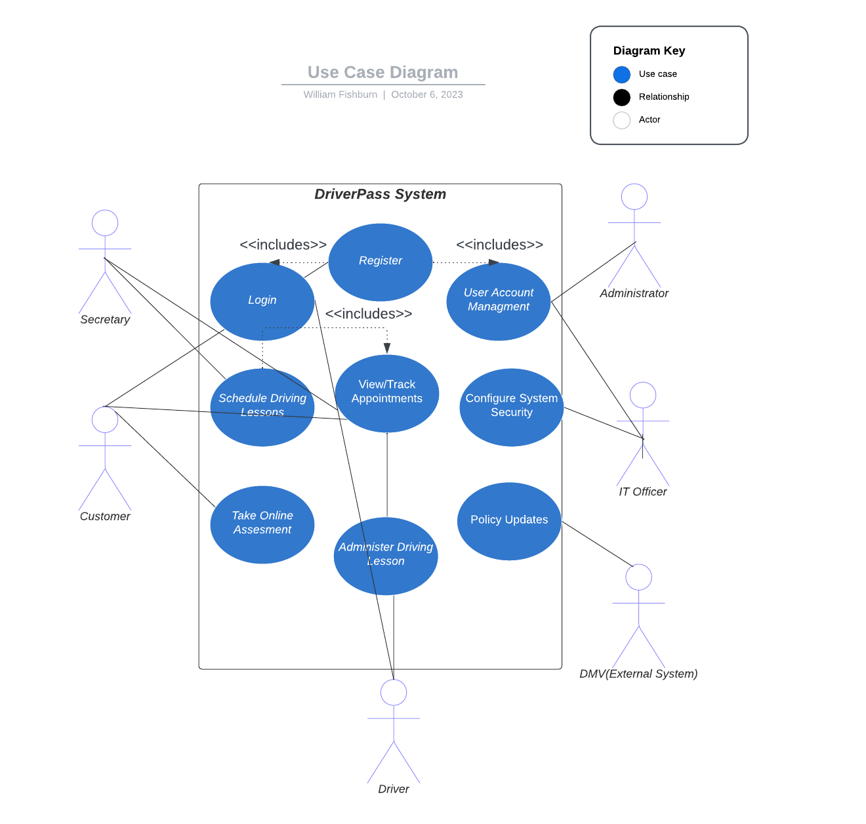

### UML Activity Diagrams

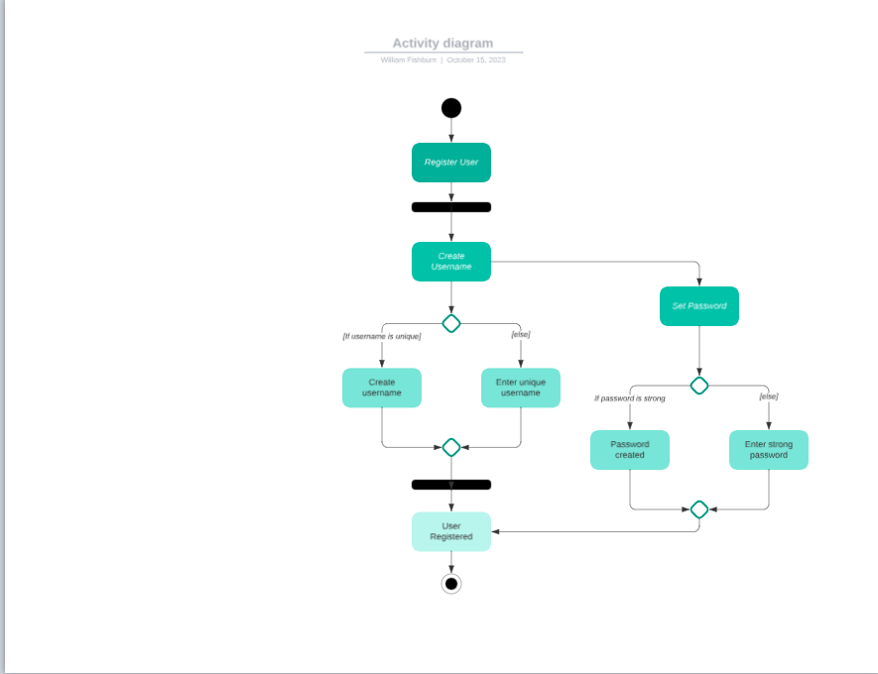

### 

### UML Sequence Diagram

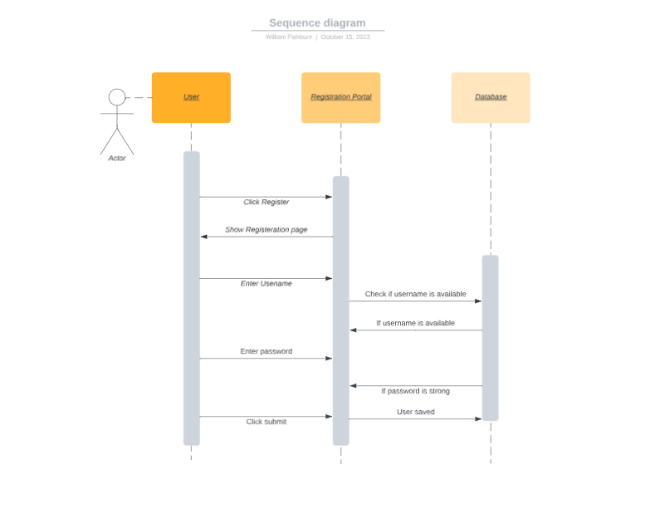

### UML Class Diagram

## 

## Technical Requirements

1. Online and Offline Access:

1.1 Hardware Requirement: The system and its contents should be accessible on both online and offline environments, on Samsung, Apple, and Google computing devices.

1.2 Software Requirement: The DriverPass system should allow the exporting of log files to .csv and .xlsx. Log contents should be allowed to be saved to local device memory.

2. Data Security:

2.1 User Rights and Roles: The system must support different user roles with varying levels of access and permissions.

2.1.1 Access Control: Full access to accounts is required for certain roles, including the ability to reset passwords and revoke access.

2.2 Authentication and Authorization: Implement secure user authentication and authorization workflows to ensure data security.

3. Data Tracking:

3.1 Audit Logs: The system should maintain an audit trail, recording activities such as appointment creation, modification, and cancellation, as well as user identification for each action.

4. Appointment Management:

4.1 User-Friendly Interface: The system should provide a user-friendly interface for managing driving lesson reservations.

4.1.1 Location Data: Capture pickup and drop-off locations.

4.2 Different Packages: Support for different driving lesson packages, each with its own features and pricing.

4.3 Customization: Allow the possibility of customizing and disabling packages for future adjustments.

5. User Management:

5.1 User Types: The system should accommodate various user types, including administrators, IT officers, secretaries, drivers, and customers.

5.1.1 Password Reset: Implement a way for users to reset their passwords if forgotten.

5.2 Online User Actions: Customers should be able to make, cancel, and modify appointments online through their accounts.

5.3 Data Collection: When a customer registers, the system should collect essential information, such as name, address, phone number, and credit card details.

6. DMV Compliance:

6.1 Data Updates: Ensure that the system can receive updates from the DMV regarding changes to rules and policies.

6.1.1 Notification: Send notifications when updates from the DMV are available.

7. Web-Based System:

7.1 Cloud Infrastructure: Host the system in the cloud to ensure scalability and reliability.

7.2 Web Interface Design: Create a web-based interface that provides a user-friendly experience.

7.2.1 Browser-based: The interface should be fully compatible with commonly used browsers, including Safari, Google Chrome, MS Edge, Brave, and Firefox.

8. Interface Design:

8.1 UI Design: Configure the interface based upon the sketch provided by DriverPass.

8.2 Check Progress: Display progress information on tests taken, showing status, time taken, score, and other pertinent details.

8.3 Driver Notes: Display comments and feedback entered by the driving instructor.

9. Iterative Development:

9.1 Flexibility: Plan for future development, such as adding or removing modules.